**OS Assignment Unit 1**

Name: Adithya M SRN: PES1UG20CS621 SECTION: K

1. Write a program to create a child process which lists all files in the current directory along with the size. (Avoid creation of zombie process)

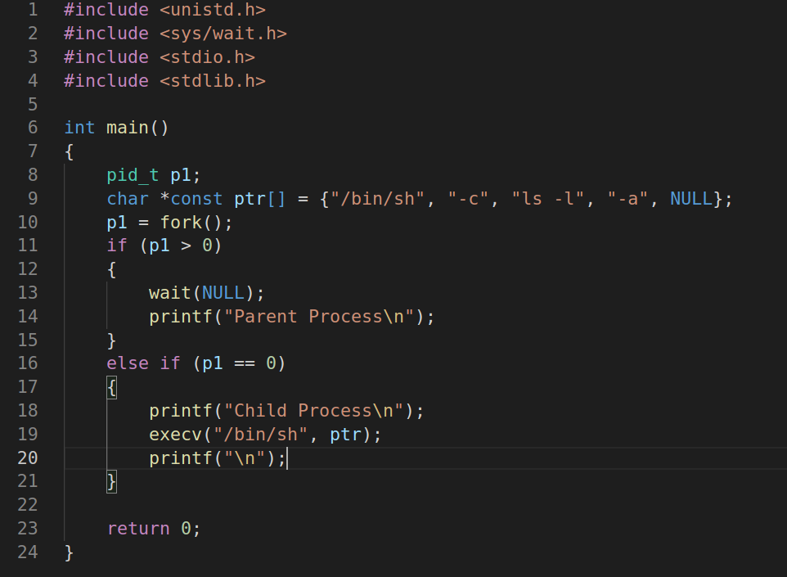

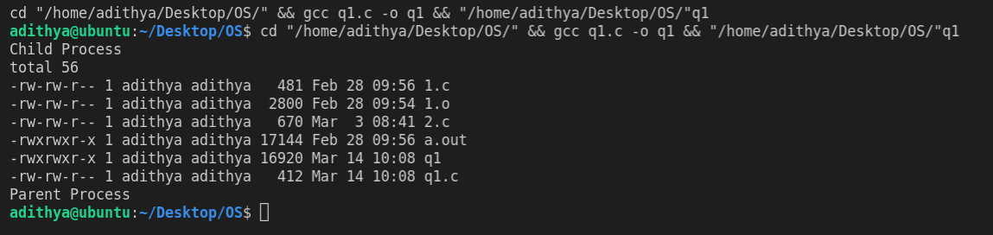

1. Create a global array with values [1, 6, 2, 4, 5, 8, 9, 0]. Sort the same within the child process, and display the values in the parent process. Are the displayed values in the sorted order? If not, why?

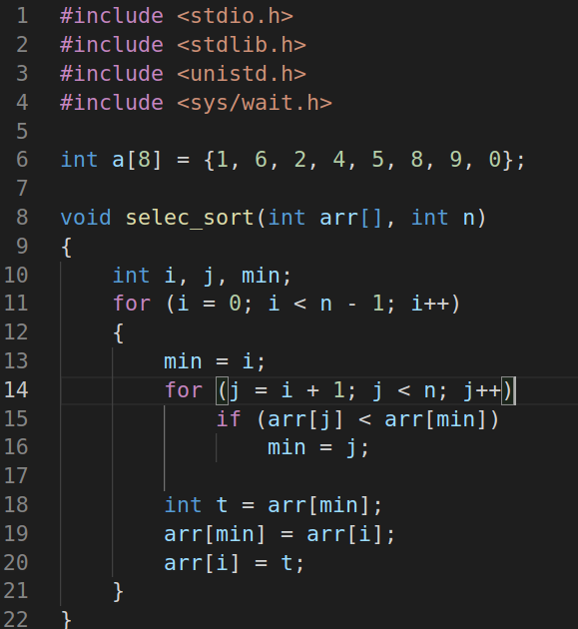

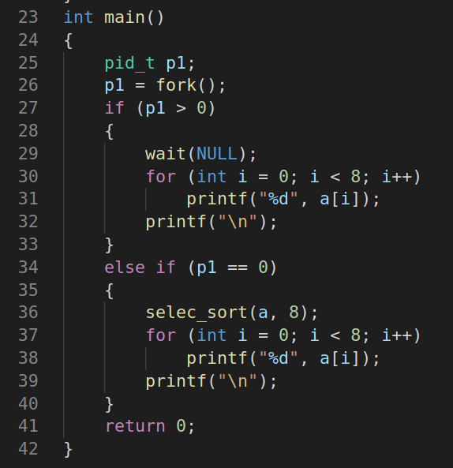

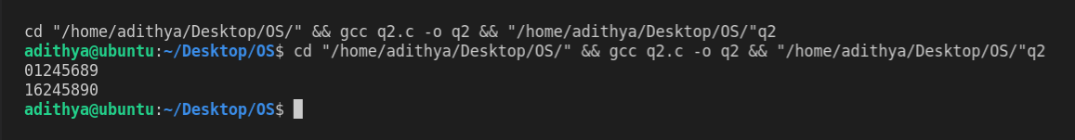

1. Write a program which accepts two integers x, and y. Now use exec to execute another user defined program that prints the sum of x and y.